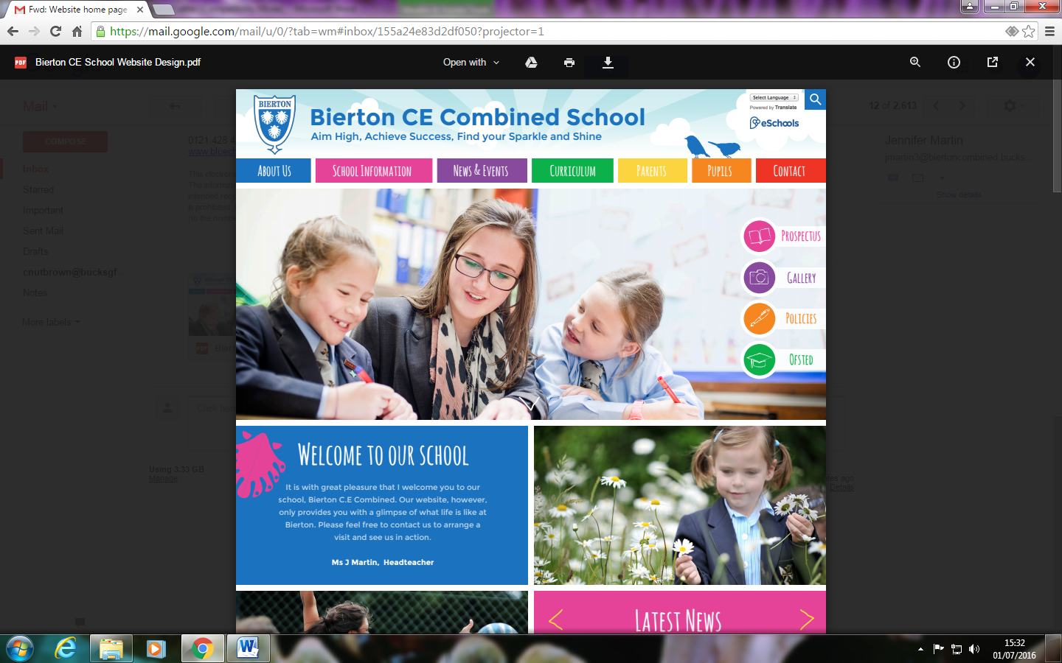
Nursery Admissions Application Form
*Please refer to our Fees and Admissions Policy for more detail about the application process. This is available on the school website.*
1) Child’s Details:
The legal surname is the one on your child’s birth certificate, adoption certificate or change of name deed poll. Please tell us if your child uses a different surname on a day to day basis.
Legal Surname: |  | First name (s):
Date of Birth: |  | Middle name (s):
Place of Birth: |  | Gender:
Languages used at home:
Main language:

The address on the application form should be your child’s normal home address at the time of application. We may ask for proof of address should this be necessary.
Home Address: | Postcode:
Name and Address of current (or most recent) school/nursery/playgroup  (if applicable): | If now left this setting, please give last date of attendance:
Permission to contact previous setting: | Yes / No

2) Your details:
Parent/Carer 1:
Relationship to child:
Name of parent:
Date of Birth:
National Insurance No:
Address:
Postcode:
Email address:
Daytime Contact No:
Alternative Contact No:

Parent/Carer 2:
Relationship to child:
Name of parent:
Date of Birth:
National Insurance No:
Address:
Postcode:
Email address:
Daytime Contact No:
Alternative Contact No:

If another adult has parental responsibility but does not live at the same address as the child, please provide their relationship to your child, their name and their address:
You may find the following information regarding parental responsibility useful: ‘if a father is not married to a child’s mother, it may only be the mother who has responsibility for the child in law. This is automatic, from the birth of the child. The father may not have parental responsibility automatically, and can only acquire it by the mother giving it to him, or by the court ordering it. If the child was born after the 1st December 2003 and the father’s name is on the birth certificate he will also have parental responsibility.’

Are you applying on behalf of a ‘child in care’ of a Local Authority? | Yes / No  If ‘Yes’ please tell us which local authority supports the child and give a social worker contact details as follows:  Social worker contact name:  Telephone number:  Local Authority:

Does your child have an Educational, Health and Care Plan (EHCP)? | Yes / No  If yes, please attach to application
Does your child have an Special Educational Needs (SEN) Support Plan? | Yes / No  If yes, please attach to application
Does your child have an Assess, Plan, Do, Review (APDR) plan? | Yes / No  If yes, please attach to application
Does your child have any medical issues we need to be made aware of?  *Please note, if your child has an allergy, a healthcare plan will be required. Please ask for a copy from the school office. Please also supply evidence of the allergy from the NHS* | Yes / No  If yes, please give further detail:
Do you have any concerns about your child’s development? | Yes / No  If yes, please give further detail:
Does your child have any siblings attending Bierton CE Combined School or will they have at the point of entry? | Yes / No  If ‘Yes’, please give details of siblings name and date of birth:
Has your child been entitled to 2 year old funding? | Yes / No
Do you believe your child may meet the criteria for Early Years Pupil Premium? | Yes / No
Do you believe your child may meet the criteria for the three/four year old extended entitlement (30 hours)? | Yes / No  If ‘Yes’ a code will need to be provided before the additional hours can be accessed/claimed. Please apply for 30 hours childcare at childcare-support.tax.service.gov.uk
*We will request codes in the event you are allocated a place.
3) Preference of session times:
Please tick the tables below, indicating the preferred session you would like your child to attend and whether you think the session would be funded or fee paying.
Please note that:
- expressing a preference does not guarantee availability.
- you can only have 5 morning or 5 afternoon sessions or 5 full day sessions. Please make sure your choice below reflects this.
- if you wish to take up a full time place, you will need to pay for the lunch club.
- if you are requesting a 30 hour funded place this will be subject to a valid eligibility code that we have to verify with Bucks County Council. In the event you have reserved a 30 hour place and you cannot prove an eligibility code, you will either have to reduce the sessions or be subject to the relevant fees.
 | Monday | Tuesday | Wednesday | Thursday | Friday
Morning  Funded/paid  £15 per session | 8.30am- 11.30am
Lunch club  Paid  £6 per session | 11.30am-12.30pm | 11.30am-12.30pm | 11.30am-12.30pm | 11.30am-12.30pm | 11.30am-12.30pm
Afternoon  Funded/paid  £15 per session | 12.30pm-3.30pm

Most children are eligible for funding in the term after their 3rd birthday. Please indicate when you would like your child to start should a place become available.
Terms | Indicate year
Terms | 2023 | 2024 | 2025 | 2026
April (Summer term)
September (Autumn term)
January (Spring term)

4) Parental declaration:

I certify that I have parental responsibility for the child named in Section 1, and that this application has the agreement of all parents/carers listed in Section 2.
I confirm that the information I have provided is to the best of my knowledge correct and up to date. I understand if I give any false or deliberately misleading information on this form and / or supporting papers or withhold any relevant information, this may lead to the withdrawal of an offer of a nursery place to my child.
Signature of parent/carer:
Date:

